SpaceAndro

음식 추천 프로그램

For<음식 추천해주는 어플리케이션>

Version <0.2.5>

2024.06.03

제출자 : 송원석

팀장 : 송원석

팀원 : 문승신

팀원 : 김지민

팀원 : 박상원

SpaceAndro는 송원석 문승신 김지민 박상원이 참여한 프로젝트입니다

최초 사용자의 정보를 입력 받아 그정보를 바탕으로 날씨 날짜등의 상황을 고려하여 음식을 추천하는 어플리케이션을 만드는 프로젝트입니다.

개정 이력

|  |  |  |  |
| --- | --- | --- | --- |
| **Date** | **Version** | **Description** | **Author** |
| <2024/03/26> | 0.1.1 | SpaceAndro문서를 생성함 | 송원석 |
| <2024/03/26> | 0.1.2 | SpaceAndro문서를 수정함 | 문승신 |
| <2024/04/16> | 0.1.3 | 프로젝트 계획서 작성 | 문승신 |
| <2024/04/29> | 0.1.4 | AI 모델 샘플 파일 작성 | 문승신 |
| <2024/04/30> | 0.1.5 | 전체 문서 수정 | 송원석 |
| <2024/05/07> | 0.1.6 | ERD 그림 추가, 표지 버전 수정 | 김지민 |
| <2024/05/07> | 0.1.7 | ERD 수정 | 김지민 |
| <2024/05/30> | 0.1.8 | 메인홈페이지 코드추가 및 이미지 추가 | 송원석 |
| <2024/05/30> | 0.1.9 | 화면 설계 이미지 추가 | 박상원 |
| <2024/05/30> | 0.2.0 | 로그인,회원가입,설문조사 코드 추가 | 박상원 |
| <2024/05/30> | 0.2.1 | 로그인,회원가입,설문조사 이미지 추가 | 박상원 |
| <2024/05/30> | 0.2.2 | 일정 추가(차트) | 송원석 |
| <2024/06/03> | 0.2.3 | 음식추천,식당추천,음식캘린더,먹은음식내역,내정보 페이지 기초구성 | 송원석 |
| <2024/06/03> | 0.2.4 | 음식추천페이지 날씨,영양성분,음식 화면구성 | 송원석 |
| <2024/06/03> | 0.2.5 | 음식 캘린더 화면 구성 및 기본디자인,캘린더디자인 css파일 분리 | 송원석 |
|  |  |  |  |
|  |  |  |  |
|  |  |  |  |
|  |  |  |  |
|  |  |  |  |

목차

# 서론

* 최초 사용자의 정보를 입력받아 그정보를 바탕으로 날씨 날짜를 고려하여 음식을 추천해주는 어플리케이션을 만드는 프로젝트입니다.

## 개요

* 현대인의 바쁜 일상속에서 음식을 빠르게 선택하는것에 어려움이 있을수있습니다 이러한 문제를 해결해줄수 있는 어플리케이션을 만들어보고싶다고 생각해 시작하게 되었습니다.

## 목표

* 사용자 친화적인 인터페이스를 통해 날씨와 날짜를 고려하여 음식 추천서비스를 제공하는것입니다
* 항상 같은 날씨에 똑같은음식을 추천해주는 것에 대해 주의하여야합니다.

## 기대효과

* 음식 선택시간 단축 ,내가 언제 무슨 음식을 먹었는지 음식 캘린더 작성

# 본론

## 도구

* 파이썬,자바,DB

## 업무분장

* 데이터베이스
* 메인홈페이지,로그인폼,회원가입폼,회원탈퇴폼,캘린더폼(자바)
* AI모델(파이썬)

## 일정

## 화면설계

* *하단 그림 참조*

## UI

* 사용자 친화 디자인, 파스텔톤의 부드러운 색배열

## UX

* 기능적 요구사항 : 사용자 위치 기반 날씨 정보 획득, 날씨 및 기온에 따른 음식추천, 과거 선택 데이터 기반 추천 개선

## ERD

## 메인홈페이지(송원석)

### Index.html

<!DOCTYPE html>

<html xmlns="http://www.thymeleaf.org" lang="ko">

<head>

<meta charset="UTF-8">

<meta name="viewport" content="width=device-width, initial-scale=1.0">

<title>Space - 음식 추천</title>

<link rel="stylesheet" href="/css/styles.css">

<script src="/js/weather.js" defer></script>

<script>

document.addEventListener("DOMContentLoaded", **function**() {

**const** links = document.querySelectorAll(".nav-wrapper a");

links.forEach(link **=>** {

link.addEventListener("click", **function**(event) {

event.preventDefault();

links.forEach(link **=>** link.classList.remove("active"));

this.classList.add("active");

**const** href = this.getAttribute("href");

**const** content = document.querySelector(".content");

content.style.animation = "fadeOut 1s forwards";

setTimeout(() **=>** {

window.location.href = href;

}, 1000);

});

});

// Footer visibility control

**const** footer = document.querySelector("footer");

**let** lastScrollTop = 0;

window.addEventListener("scroll", **function**() {

**const** scrollTop = window.pageYOffset || document.documentElement.scrollTop;

if (scrollTop > lastScrollTop) {

// Scroll down

footer.classList.add("footer-hidden");

} else {

// Scroll up

footer.classList.remove("footer-hidden");

}

lastScrollTop = scrollTop;

});

});

</script>

</head>

<body>

<header>

<div class="date">

<span th:text="${date}"></span>

</div>

<div class="title">Space</div>

<div class="login-button"><button>로그인</button></div>

</header>

<div class="nav-wrapper">

<a href="/" class="active">음식 추천</a>

<a href="/restaurant">식당 추천</a>

<a href="/calendar">음식 캘린더</a>

<a href="/history">지난 먹은 음식 내역</a>

<a href="/profile">내 정보</a>

</div>

<div class="content">

<div class="weather-box">

<h2>현재 날씨</h2>

<!-- 날씨 정보가 여기 표시됩니다 -->

</div>

<div class="nutrition-box">

<h2>영양성분 확인</h2>

<!-- 영양성분 정보 추가 -->

</div>

<div class="recommendation-box">

<h2>오늘의 음식 추천</h2>

<p th:text="${recommendedFood}"></p>

</div>

</div>

<footer class="footer">

<p>© 2024 Space. All rights reserved.</p>

</footer>

</body>

</html>

### FoodController.java

* 소스코드
* package com.rubypaper.controller;
* import org.springframework.stereotype.Controller;
* import org.springframework.ui.Model;
* import org.springframework.web.bind.annotation.GetMapping;
* import java.time.LocalDate;
* import java.util.List;
* import java.util.Random;
* @Controller
* public class FoodController {
* @GetMapping("/")
* public String home(Model model) {
* // 현재 날짜를 모델에 추가
* model.addAttribute("date", LocalDate.now().toString().replace("-", "."));
* // 음식 추천 로직
* List<String> foods = List.of("비빔밥", "된장찌개", "김치찌개", "불고기", "떡볶이");
* String recommendedFood = foods.get(new Random().nextInt(foods.size()));
* // 추천 음식을 모델에 추가
* model.addAttribute("recommendedFood", recommendedFood);
* return "index";
* }
* }

## 식당추천,음식캘린더,먹은음식내역,내정보 페이지(송원석)

### 식당추천(restaurant.html)

<!DOCTYPE html>

<html xmlns="http://www.thymeleaf.org" lang="ko">

<head>

<meta charset="UTF-8">

<meta name="viewport" content="width=device-width, initial-scale=1.0">

<title>Space - 식당 추천</title>

<link rel="stylesheet" href="/css/styles.css">

<script>

document.addEventListener("DOMContentLoaded", **function**() {

**const** links = document.querySelectorAll(".nav-wrapper a");

**function** setActiveLink() {

**const** path = window.location.pathname;

links.forEach(link **=>** {

link.classList.toggle("active", link.getAttribute("href") === path);

});

}

// Set active link on page load

setActiveLink();

// Footer visibility control

**const** footer = document.querySelector("footer");

**let** lastScrollTop = 0;

window.addEventListener("scroll", **function**() {

**const** scrollTop = window.pageYOffset || document.documentElement.scrollTop;

if (scrollTop > lastScrollTop) {

// Scroll down

footer.classList.add("footer-hidden");

} else {

// Scroll up

footer.classList.remove("footer-hidden");

}

lastScrollTop = scrollTop;

});

});

</script>

</head>

<body>

<header>

<div class="date">

<span th:text="${date}"></span>

</div>

<div class="title">Space</div>

<div class="login-button"><button>로그인</button></div>

</header>

<div class="nav-wrapper">

<a href="/">음식 추천</a>

<a href="/restaurant" class="active">식당 추천</a>

<a href="/calendar">음식 캘린더</a>

<a href="/history">지난 먹은 음식 내역</a>

<a href="/profile">내 정보</a>

</div>

<div class="content">

<div class="recommendation-box">

<h2>식당 추천</h2>

<p>추천 식당 리스트</p>

</div>

</div>

<footer class="footer">

<p>© 2024 Space. All rights reserved.</p>

</footer>

</body>

</html>

### 음식캘린더(calendar.html)

<!DOCTYPE html>

<html xmlns="http://www.thymeleaf.org" lang="ko">

<head>

<meta charset="UTF-8">

<meta name="viewport" content="width=device-width, initial-scale=1.0">

<title>음식 캘린더</title>

<link rel="stylesheet" href="/css/styles.css">

<link rel="stylesheet" href="/css/calendarStyle.css">

<script>

document.addEventListener("DOMContentLoaded", **function**() {

**const** links = document.querySelectorAll(".nav-wrapper a");

links.forEach(link **=>** {

link.addEventListener("click", **function**(event) {

event.preventDefault();

links.forEach(link **=>** link.classList.remove("active"));

this.classList.add("active");

**const** href = this.getAttribute("href");

**const** content = document.querySelector(".content");

content.style.animation = "fadeOut 1s forwards";

setTimeout(() **=>** {

window.location.href = href;

}, 1000);

});

});

**function** createCalendar(year, month) {

**const** calendarContainer = document.querySelector(".calendar");

calendarContainer.innerHTML = "";

**const** firstDay = new Date(year, month, 1).getDay();

**const** lastDate = new Date(year, month + 1, 0).getDate();

for (**let** i = 0; i < firstDay; i++) {

**const** emptyCell = document.createElement("div");

calendarContainer.appendChild(emptyCell);

}

for (**let** date = 1; date <= lastDate; date++) {

**const** dayCell = document.createElement("div");

dayCell.classList.add("day");

dayCell.setAttribute("data-date", `${year}-${month + 1}-${date}`);

dayCell.innerHTML = `

<div>${date}</div>

<textarea rows="4"></textarea>

<button class="save-button">저장</button>

`;

calendarContainer.appendChild(dayCell);

}

**const** days = document.querySelectorAll(".day");

days.forEach(day **=>** {

**const** date = day.getAttribute("data-date");

**const** savedData = localStorage.getItem(date);

if (savedData) {

day.querySelector("textarea").value = savedData;

}

day.querySelector(".save-button").addEventListener("click", **function**() {

**const** data = day.querySelector("textarea").value;

localStorage.setItem(date, data);

alert("저장되었습니다.");

});

});

}

**const** today = new Date();

**const** currentYear = today.getFullYear();

**const** currentMonth = today.getMonth();

createCalendar(currentYear, currentMonth);

// Footer visibility control

**const** footer = document.querySelector("footer");

**let** lastScrollTop = 0;

window.addEventListener("scroll", **function**() {

**const** scrollTop = window.pageYOffset || document.documentElement.scrollTop;

if (scrollTop > lastScrollTop) {

// Scroll down

footer.classList.add("footer-hidden");

} else {

// Scroll up

footer.classList.remove("footer-hidden");

}

lastScrollTop = scrollTop;

});

});

</script>

</head>

<body>

<header class="header">

<div class="date">

<span th:text="${date}"></span>

</div>

<div class="title">Space</div>

<div class="login-button"><button>로그인</button></div>

</header>

<div class="nav-wrapper">

<a href="/">음식 추천</a>

<a href="/restaurant">식당 추천</a>

<a href="/calendar" class="active">음식 캘린더</a>

<a href="/history">지난 먹은 음식 내역</a>

<a href="/profile">내 정보</a>

</div>

<div class="content">

<div class="recommendation-box">

<h2>음식 캘린더</h2>

<div class="calendar"></div>

</div>

</div>

<footer class="footer">

<p>© 2024 Space. All rights reserved.</p>

</footer>

</body>

</html>

### 지난 먹은 음식 내역(history.html)

<!DOCTYPE html>

<html xmlns="http://www.thymeleaf.org" lang="ko">

<head>

<meta charset="UTF-8">

<meta name="viewport" content="width=device-width, initial-scale=1.0">

<title>Space - 지난 먹은 음식 내역</title>

<link rel="stylesheet" href="/css/styles.css">

<script>

document.addEventListener("DOMContentLoaded", **function**() {

**const** links = document.querySelectorAll(".nav-wrapper a");

**function** setActiveLink() {

**const** path = window.location.pathname;

links.forEach(link **=>** {

link.classList.toggle("active", link.getAttribute("href") === path);

});

}

// Set active link on page load

setActiveLink();

// Footer visibility control

**const** footer = document.querySelector("footer");

**let** lastScrollTop = 0;

window.addEventListener("scroll", **function**() {

**const** scrollTop = window.pageYOffset || document.documentElement.scrollTop;

if (scrollTop > lastScrollTop) {

// Scroll down

footer.classList.add("footer-hidden");

} else {

// Scroll up

footer.classList.remove("footer-hidden");

}

lastScrollTop = scrollTop;

});

});

</script>

</head>

<body>

<header>

<div class="date">

<span th:text="${date}"></span>

</div>

<div class="title">Space</div>

<div class="login-button"><button>로그인</button></div>

</header>

<div class="nav-wrapper">

<a href="/">음식 추천</a>

<a href="/restaurant">식당 추천</a>

<a href="/calendar">음식 캘린더</a>

<a href="/history" class="active">지난 먹은 음식 내역</a>

<a href="/profile">내 정보</a>

</div>

<div class="content">

<div class="recommendation-box">

<h2>지난 먹은 음식 내역</h2>

<p>지난 먹은 음식 리스트</p>

</div>

</div>

<footer class="footer">

<p>© 2024 Space. All rights reserved.</p>

</footer>

</body>

</html>

### 내정보(profile.html)

<!DOCTYPE html>

<html xmlns="http://www.thymeleaf.org" lang="ko">

<head>

<meta charset="UTF-8">

<meta name="viewport" content="width=device-width, initial-scale=1.0">

<title>Space - 내 정보</title>

<link rel="stylesheet" href="/css/styles.css">

<script>

document.addEventListener("DOMContentLoaded", **function**() {

**const** links = document.querySelectorAll(".nav-wrapper a");

**function** setActiveLink() {

**const** path = window.location.pathname;

links.forEach(link **=>** {

link.classList.toggle("active", link.getAttribute("href") === path);

});

}

// Set active link on page load

setActiveLink();

// Footer visibility control

**const** footer = document.querySelector("footer");

**let** lastScrollTop = 0;

window.addEventListener("scroll", **function**() {

**const** scrollTop = window.pageYOffset || document.documentElement.scrollTop;

if (scrollTop > lastScrollTop) {

// Scroll down

footer.classList.add("footer-hidden");

} else {

// Scroll up

footer.classList.remove("footer-hidden");

}

lastScrollTop = scrollTop;

});

});

</script>

</head>

<body>

<header>

<div class="date">

<span th:text="${date}"></span>

</div>

<div class="title">Space</div>

<div class="login-button"><button>로그인</button></div>

</header>

<div class="nav-wrapper">

<a href="/">음식 추천</a>

<a href="/restaurant">식당 추천</a>

<a href="/calendar">음식 캘린더</a>

<a href="/history">지난 먹은 음식 내역</a>

<a href="/profile" class="active">내 정보</a>

</div>

<div class="content">

<div class="recommendation-box">

<h2>내 정보</h2>

<p>사용자 정보</p>

</div>

</div>

<footer class="footer">

<p>© 2024 Space. All rights reserved.</p>

</footer>

</body>

</html>

## 로그인, 회원가입, 설문조사 (이미지 하단 첨부)

## A.로그인 페이지(박상원)

<!DOCTYPE html>

<html lang="ko">

<head>

<meta charset="UTF-8">

<meta name="viewport" content="width=device-width, initial-scale=1.0">

<title>Space - 로그인</title>

<style>

@import url('https://fonts.googleapis.com/css2?family=Dancing+Script:wght@700&display=swap');

body {

font-family: Arial, sans-serif;

margin: 0;

padding: 0;

display: flex;

flex-direction: column;

min-height: 100vh;

}

header, footer {

background-color: #333;

color: white;

padding: 1em;

display: flex;

justify-content: space-between;

align-items: center;

}

header {

position: relative;

}

header .title {

position: absolute;

left: 50%;

transform: translateX(-50%);

font-size: 2.5em;

font-family: 'Dancing Script', cursive;

background: linear-gradient(90deg, rgba(255, 255, 255, 0.5) 0%, rgba(255, 255, 255, 0.2) 100%);

-webkit-background-clip: text;

color: transparent;

background-clip: text;

}

header .date {

font-size: 1em;

background: linear-gradient(90deg, rgba(255, 255, 255, 0.5) 0%, rgba(255, 255, 255, 0.2) 100%);

padding: 0.2em 0.5em;

border-radius: 10px;

}

footer {

position: fixed;

bottom: 0;

width: 100%;

justify-content: center;

}

.menu-bar {

display: flex;

justify-content: center;

gap: 20px;

}

.menu-bar button {

padding: 10px 20px;

border: none;

background-color: #888;

color: white;

cursor: pointer;

border-radius: 25px;

box-shadow: 0 4px 8px rgba(0, 0, 0, 0.2);

transition: background-color 0.3s, box-shadow 0.3s, transform 0.3s;

}

.menu-bar button:hover {

background-color: #777;

box-shadow: 0 8px 16px rgba(0, 0, 0, 0.2);

transform: translateY(-2px);

}

.menu-bar button:active {

background-color: #666;

transform: translateY(0);

}

.login-button button {

padding: 10px 20px;

border: none;

background-color: #0066cc;

color: white;

cursor: pointer;

border-radius: 25px;

box-shadow: 0 4px 8px rgba(0, 0, 0, 0.2);

transition: background-color 0.3s, box-shadow 0.3s, transform 0.3s;

}

.login-button button:hover {

background-color: #005bb5;

box-shadow: 0 8px 16px rgba(0, 0, 0, 0.2);

transform: translateY(-2px);

}

.login-button button:active {

background-color: #004999;

transform: translateY(0);

}

.content {

flex: 1;

display: flex;

justify-content: center;

align-items: center;

}

.login-container {

border: 2px solid #333;

padding: 20px;

text-align: center;

background-color: #f9f9f9;

}

.login-container label {

display: block;

margin-bottom: 10px;

color: #333;

font-weight: bold;

}

.login-container input[type="text"],

.login-container input[type="password"] {

width: 100%;

padding: 8px;

margin-bottom: 15px;

box-sizing: border-box;

border: 1px solid #ccc;

border-radius: 4px;

}

.login-container button {

width: 100%;

padding: 10px;

border: none;

border-radius: 4px;

background-color: #0066cc;

color: white;

font-size: 16px;

cursor: pointer;

transition: background-color 0.3s, box-shadow 0.3s, transform 0.3s;

}

.login-container button:hover {

background-color: #005bb5;

box-shadow: 0 8px 16px rgba(0, 0, 0, 0.2);

transform: translateY(-2px);

}

.login-container button:active {

background-color: #004999;

transform: translateY(0);

}

</style>

</head>

<body>

<header>

<h1 class="title">Space</h1>

<div class="date">2024-05-30</div>

</header>

<div class="content">

<div class="login-container">

<h2>로그인</h2>

<form action="/login" method="post">

<label for="username">아이디</label>

<input type="text" id="username" name="username" required>

<label for="password">비밀번호</label>

<input type="password" id="password" name="password" required>

<button type="submit">로그인</button>

<br><br>

<button type="submit"> 회원가입</button>

</form>

</div>

</div>

<footer>

</div>

</footer>

</body>

</html>

## B.회원가입 페이지(박상원)

<!DOCTYPE html>

<html lang="ko">

<head>

<meta charset="UTF-8">

<meta name="viewport" content="width=device-width, initial-scale=1.0">

<title>Space - 회원가입</title>

<style>

@import url('https://fonts.googleapis.com/css2?family=Dancing+Script:wght@700&display=swap');

body {

font-family: Arial, sans-serif;

margin: 0;

padding: 0;

display: flex;

flex-direction: column;

min-height: 100vh;

}

header, footer {

background-color: #333;

color: white;

padding: 1em;

display: flex;

justify-content: space-between;

align-items: center;

}

header {

position: relative;

}

header .title {

position: absolute;

left: 50%;

transform: translateX(-50%);

font-size: 2.5em;

font-family: 'Dancing Script', cursive;

background: linear-gradient(90deg, rgba(255, 255, 255, 0.5) 0%, rgba(255, 255, 255, 0.2) 100%);

-webkit-background-clip: text;

color: transparent;

background-clip: text;

}

header .date {

font-size: 1em;

background: linear-gradient(90deg, rgba(255, 255, 255, 0.5) 0%, rgba(255, 255, 255, 0.2) 100%);

padding: 0.2em 0.5em;

border-radius: 10px;

}

footer {

position: fixed;

bottom: 0;

width: 100%;

justify-content: center;

}

.menu-bar {

display: flex;

justify-content: center;

gap: 20px;

}

.menu-bar button {

padding: 10px 20px;

border: none;

background-color: #888;

color: white;

cursor: pointer;

border-radius: 25px;

box-shadow: 0 4px 8px rgba(0, 0, 0, 0.2);

transition: background-color 0.3s, box-shadow 0.3s, transform 0.3s;

}

.menu-bar button:hover {

background-color: #777;

box-shadow: 0 8px 16px rgba(0, 0, 0, 0.2);

transform: translateY(-2px);

}

.menu-bar button:active {

background-color: #666;

transform: translateY(0);

}

.signup-container {

border: 2px solid #333;

padding: 20px;

text-align: center;

background-color: #f9f9f9;

margin: 20px auto;

width: 300px;

border-radius: 8px;

}

.signup-container label {

display: block;

margin-bottom: 10px;

color: #333;

font-weight: bold;

}

.signup-container input[type="text"],

.signup-container input[type="email"],

.signup-container input[type="password"] {

width: 100%;

padding: 8px;

margin-bottom: 15px;

box-sizing: border-box;

border: 1px solid #ccc;

border-radius: 4px;

}

.signup-container button {

width: 100%;

padding: 10px;

border: none;

border-radius: 4px;

background-color: #0066cc;

color: white;

font-size: 16px;

cursor: pointer;

transition: background-color 0.3s, box-shadow 0.3s, transform 0.3s;

}

.signup-container button:hover {

background-color: #005bb5;

box-shadow: 0 8px 16px rgba(0, 0, 0, 0.2);

transform: translateY(-2px);

}

.signup-container button:active {

background-color: #004999;

transform: translateY(0);

}

</style>

</head>

<body>

<header>

<h1 class="title">Space</h1>

<div class="date">2024-05-30</div>

</header>

<div class="signup-container">

<h2>회원가입</h2>

<form action="/signup" method="post">

<label for="username">사용자명</label>

<input type="text" id="username" name="username" required>

<label for="email">이메일</label>

<input type="email" id="email" name="email" required>

<label for="password">비밀번호</label>

<input type="password" id="password" name="password" required>

<button type="submit">가입하기</button>

</form>

</div>

<footer>

</footer>

</body>

</html>

## C.설문조사 페이지(박상원)

<!DOCTYPE html>

<html lang="ko">

<head>

<meta charset="UTF-8">

<meta name="viewport" content="width=device-width, initial-scale=1.0">

<title>설문조사</title>

<style>

@import url('https://fonts.googleapis.com/css2?family=Dancing+Script:wght@700&display=swap');

body {

font-family: Arial, sans-serif;

margin: 0;

padding: 0;

display: flex;

flex-direction: column;

min-height: 100vh;

}

header, footer {

background-color: #333;

color: white;

padding: 1em;

display: flex;

justify-content: space-between;

align-items: center;

}

header {

position: relative;

}

header .title {

position: absolute;

left: 50%;

transform: translateX(-50%);

font-size: 2.5em;

font-family: 'Dancing Script', cursive;

background: linear-gradient(90deg, rgba(255, 255, 255, 0.5) 0%, rgba(255, 255, 255, 0.2) 100%);

-webkit-background-clip: text;

color: transparent;

background-clip: text;

}

header .date {

font-size: 1em;

background: linear-gradient(90deg, rgba(255, 255, 255, 0.5) 0%, rgba(255, 255, 255, 0.2) 100%);

padding: 0.2em 0.5em;

border-radius: 10px;

}

footer {

position: fixed;

bottom: 0;

width: 100%;

justify-content: center;

}

.menu-bar {

display: flex;

justify-content: center;

gap: 20px;

}

.menu-bar button {

padding: 10px 20px;

border: none;

background-color: #888;

color: white;

cursor: pointer;

border-radius: 25px;

box-shadow: 0 4px 8px rgba(0, 0, 0, 0.2);

transition: background-color 0.3s, box-shadow 0.3s, transform 0.3s;

}

.menu-bar button:hover {

background-color: #777;

box-shadow: 0 8px 16px rgba(0, 0, 0, 0.2);

transform: translateY(-2px);

}

.menu-bar button:active {

background-color: #666;

transform: translateY(0);

}

.login-button button {

padding: 10px 20px;

border: none;

background-color: #0066cc;

color: white;

cursor: pointer;

border-radius: 25px;

box-shadow: 0 4px 8px rgba(0, 0, 0, 0.2);

transition: background-color 0.3s, box-shadow 0.3s, transform 0.3s;

}

.login-button button:hover {

background-color: #005bb5;

box-shadow: 0 8px 16px rgba(0, 0, 0, 0.2);

transform: translateY(-2px);

}

.login-button button:active {

background-color: #004999;

transform: translateY(0);

}

.content {

flex: 1;

display: flex;

justify-content: center;

align-items: center;

}

.recommendation-box {

border: 2px solid #333;

padding: 20px;

text-align: center;

background-color: #f9f9f9;

}

.survey-container {

background-color: white;

padding: 20px;

border-radius: 8px;

box-shadow: 0 0 10px rgba(0, 0, 0, 0.1);

width: 400px;

text-align: center;

margin-top: 20px;

}

.survey-container h2 {

margin-bottom: 20px;

}

.survey-question {

margin-bottom: 15px;

text-align: left;

}

.survey-question label {

display: inline-block;

margin-right: 15px;

}

.survey-container button {

width: 100%;

padding: 10px;

border: none;

border-radius: 4px;

background-color: #5cb85c;

color: white;

font-size: 16px;

cursor: pointer;

}

.survey-container button:hover {

background-color: #4cae4c;

}

</style>

</head>

<body>

<header>

<h1 class="title">Space</h1>

<span class="date">2024-05-30</span>

</header>

<div class="content">

<body>

<div class="survey-container">

<h2>설문조사</h2>

<div class="survey-question">

<label for="question1">질문 1: 선호하는 음식을 선택하세요</label>

<br>

<input type="checkbox" id="question1-hansik" name="question1" value="한식">

<label for="question1-hansik">한식</label>

<input type="checkbox" id="question1-jungsik" name="question1" value="중식">

<label for="question1-jungsik">중식</label>

<input type="checkbox" id="question1-yangsik" name="question1" value="양식">

<label for="question1-yangsik">양식</label>

</div>

<div class="survey-question">

<label for="question2">질문 2: 주로 어디에서 음식을 섭취하시나요?</label>

<br>

<input type="checkbox" id="question2-home" name="question2" value="집">

<label for="question2-home">집</label>

<input type="checkbox" id="question2-restaurant" name="question2" value="식당">

<label for="question2-restaurant">식당</label>

<input type="checkbox" id="question2-dining-out" name="question2" value="외식">

<label for="question2-dining-out">외식</label>

</div>

<div class="survey-question">

<label for="question3">질문 3: 알러지가 있나요? (있을 경우 선택해주세요)</label>

<input type="checkbox" id="question3-sesame" name="question3" value="참깨">

<label for="question3-sesame">참깨</label>

<input type="checkbox" id="question3-shellfish" name="question3" value="갑각류">

<label for="question3-shellfish">갑각류</label>

<input type="checkbox" id="question3-soy" name="question3" value="대두">

<label for="question3-soy">대두</label>

<input type="checkbox" id="question3-milk" name="question3" value="우유">

<label for="question3-milk">우유</label>

<br>

<input type="checkbox" id="question3-milk" name="question3" value="쌀">

<label for="question3-milk">쌀</label>

<input type="checkbox" id="question3-milk" name="question3" value="잣">

<label for="question3-milk">잣</label>

<input type="checkbox" id="question3-milk" name="question3" value="복숭아">

<label for="question3-milk">복숭아</label>

<input type="checkbox" id="question3-milk" name="question3" value="토마토">

<label for="question3-milk">토마토</label>

<input type="checkbox" id="question3-milk" name="question3" value="난류">

<label for="question3-milk">난류</label>

<br>

<input type="checkbox" id="question3-milk" name="question3" value="오징어">

<label for="question3-milk">오징어</label>

<input type="checkbox" id="question3-milk" name="question3" value="게">

<label for="question3-milk">게</label>

</div>

<button type="submit">제출하기</button>

</div>

<footer>

</footer>

</body>

</html>

# 로그인

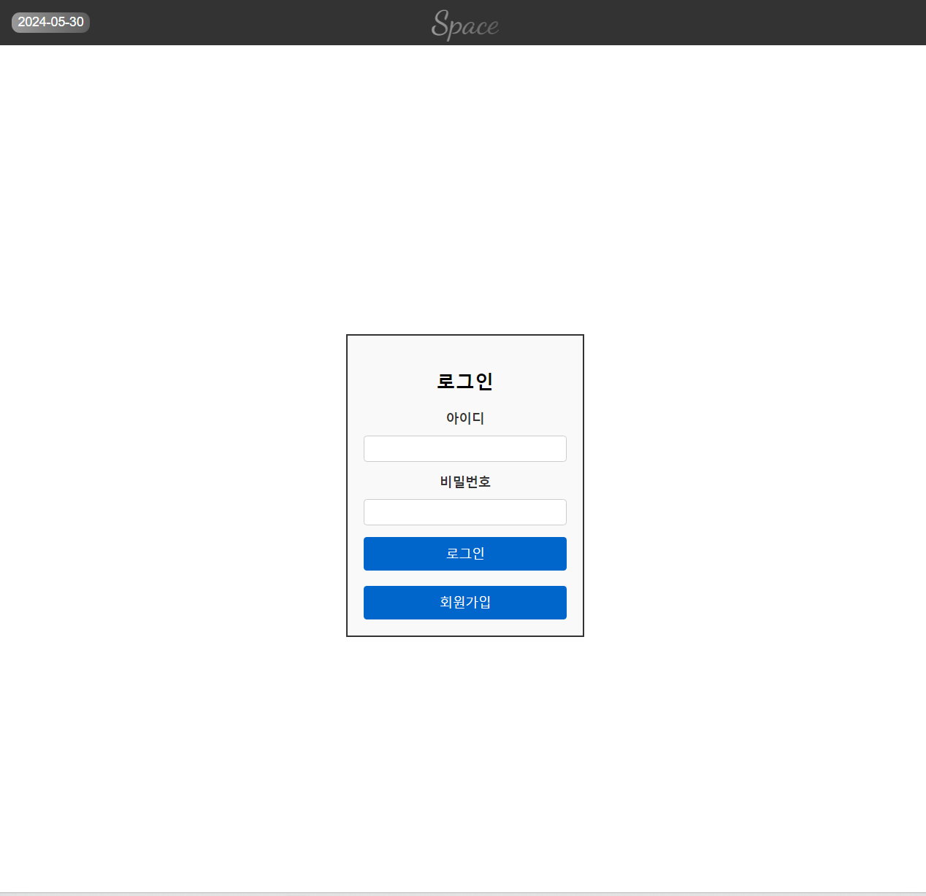

# 회원가입

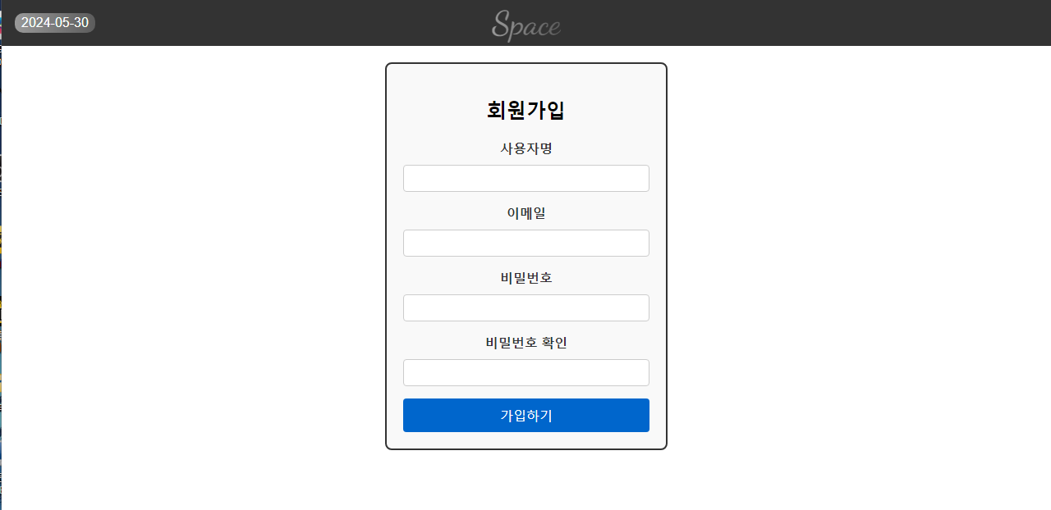

# 설문조사

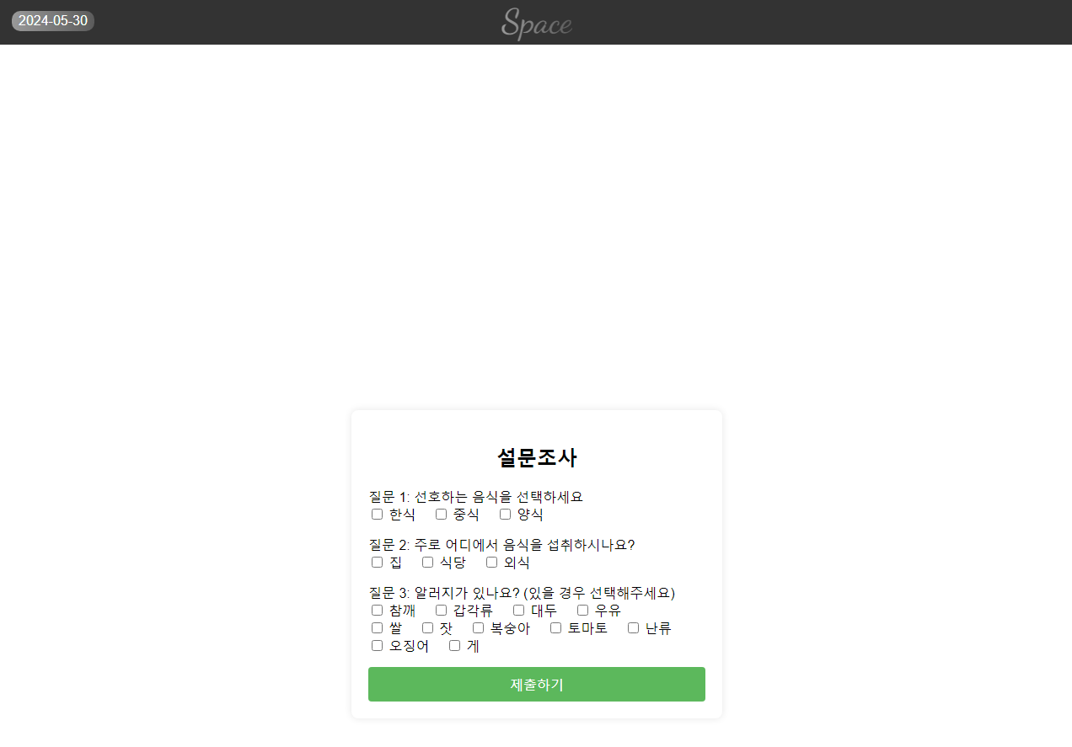

# 결론

## Configuration Identification

# 참고문헌

* 아마존 ai 모델 교육

# 일정

추가-송원석

## 기본 화면 디자인(css파일) 송원석

### 기본 디자인(styles.css)

@import url('https://fonts.googleapis.com/css2?family=Dancing+Script:wght@700&display=swap');

@import url('https://cdnjs.cloudflare.com/ajax/libs/materialize/1.0.0/css/materialize.min.css');

body {

font-family: Arial, sans-serif;

margin: 0;

padding: 0;

display: flex;

flex-direction: column;

min-height: 100vh;

}

header, footer {

background-color: #333;

color: white;

padding: 1em;

display: flex;

justify-content: space-between;

align-items: center;

}

header {

position: relative;

}

header .title {

position: absolute;

left: 50%;

transform: translateX(-50%);

font-size: 2.5em;

font-family: 'Dancing Script', cursive;

background: linear-gradient(90deg, rgba(255, 255, 255, 0.5) 0%, rgba(255, 255, 255, 0.2) 100%);

-webkit-background-clip: text;

color: transparent;

background-clip: text;

}

header .date {

font-size: 1em;

background: linear-gradient(90deg, rgba(255, 255, 255, 0.5) 0%, rgba(255, 255, 255, 0.2) 100%);

padding: 0.2em 0.5em;

border-radius: 10px;

}

footer {

position: fixed;

bottom: 0;

width: 100%;

justify-content: center;

}

.header, .footer {

transition: transform 0.3s ease;

}

.nav-wrapper {

display: flex;

justify-content: space-around;

background-color: #d0d0d0;

padding: 10px;

border-radius: 10px;

}

.nav-wrapper a {

flex: 1; /* 모든 버튼의 크기를 통일 */

text-align: center;

color: rgb(0, 0, 0);

font-size: 1.2em;

font-weight: 600;

padding: 1em;

text-decoration: none;

transition: background-color 0.3s, box-shadow 0.3s;

border-radius: 10px; /* 둥글게 */

box-shadow: 0 4px #999; /* 3D 효과 */

}

.nav-wrapper a:hover {

background-color: #b0b0b0;

box-shadow: 0 2px #666;

}

.nav-wrapper a:active {

box-shadow: 0 1px #666;

transform: translateY(2px);

}

.nav-wrapper a.active {

background-color: #888; /* 눌린 상태의 버튼 색상 */

}

.content {

flex: 1;

display: flex;

justify-content: center;

align-items: center;

flex-direction: column;

padding: 20px;

opacity: 0;

animation: fadeIn 1s forwards;

}

.recommendation-box, .nutrition-box, .weather-box {

border: 2px solid #333;

padding: 20px;

text-align: left;

background-color: #f9f9f9;

border-radius: 10px; /* 둥글게 */

width: 80%;

margin-bottom: 20px;

box-shadow: 0 4px 8px rgba(0, 0, 0, 0.1);

}

.recommendation-box h2, .nutrition-box h2, .weather-box h2 {

font-size: 1em; /* 작은 제목 */

margin-bottom: 10px;

}

.recommendation-box p {

font-size: 2em; /* 큰 음식 이름 */

}

@keyframes fadeIn {

to {

opacity: 1;

}

}

@keyframes fadeOut {

to {

opacity: 0;

}

}

### 캘린더 디자인(calendarStyle.css)

.calendar {

display: grid;

grid-template-columns: repeat(7, 1fr);

gap: 10px;

margin-top: 20px;

padding: 20px;

border: 2px solid #a0e7e5;

border-radius: 15px;

background-color: #e0f7fa;

}

.day {

border: 1px solid #a0e7e5;

border-radius: 10px;

padding: 10px;

text-align: center;

background-color: #b2ebf2;

position: relative;

box-shadow: 0 4px 8px rgba(0, 0, 0, 0.1);

}

.day div {

font-size: 1.2em;

font-weight: bold;

margin-bottom: 5px;

}

.day textarea {

width: 100%;

box-sizing: border-box;

border-radius: 5px;

border: 1px solid #80deea;

padding: 5px;

font-size: 1em;

background-color: #e0f7fa;

}

.day .save-button {

display: block;

margin-top: 5px;

padding: 5px;

background-color: #4dd0e1;

color: white;

border: none;

cursor: pointer;

border-radius: 5px;

font-size: 0.9em;

}

.day .save-button:hover {

background-color: #26c6da;

}

/*.footer-hidden {

transform: translateY(100%);

}

*/



